Contents

Room Module Model…………………..……………  
 - Room & RoomImage  
 - Room Additional Details & Facility  
 - Room Feedback, Comment  
 - Room Facility  
 - Room Feedback  
 - Room Booking

**Room Module Model**

**Room & RoomImage**

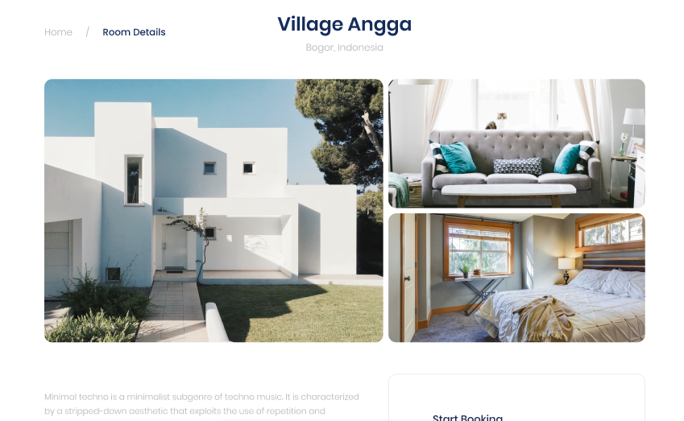

**هنلاحظ أن ال Fields اللي معانا لحد الآن هما:**

**public** class Room

**{**

**public** int Id **{** **get;** **set;** **}**

**public** string Title **{** **get;** **set;** **}**

**public** string Description **{** **get;** **set;** **}**

**public** string Location **{** **get;** **set;** **}**

// Navigation properties

**public** ICollection**<**RoomImage**>** Images **{** **get;** **set;** **}**

**}**

**سؤال: ممكن بدل ما نخلي RoomNumber يكون int ممكن نخليه string ويكون مثلاً الدور بتاع الغرفه ومعاه ترتيبها فمثلاً A-2؟**

**وبالنسبه للـ Collection الخاص بال Images، فيه نقطعه وهوا أن في ال Dashboard Table بيعرض صوره واحده عشان كده عاملين IsMainImage bool**

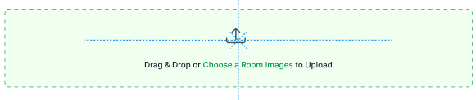

**public** class RoomImage

**{**

**public** int Id **{** **get;** **set;** **}**

**public** string **FileName** **{** **get;** **set;** **}**

**public** string **ContentType** **{** **get;** **set;** **}**

**public** byte**[]** **FileData** **{** **get;** **set;** **}**

**public** long **FileSize** **{** **get;** **set;** **}**

**public bool IsMainImage { get; set; }**

**public** DateTime UploadDate **{** **get;** **set;** **}**

// Foreign key

**public** int RoomId **{** **get;** **set;** **}**

**public** Room Room **{** **get;** **set;** **}**

**}**

**To handle file Uploads:**

1. **FileName**: Stores the original name of the uploaded file
2. **ContentType**: Stores the MIME type of the file (e.g., "image/jpeg", "image/png")
3. **FileData**: The actual file content stored as a byte array
4. **FileSize**: The size of the file in bytes

This structure will allow you to:

* Store the actual file data in the database
* Handle drag & drop uploads
* Maintain file metadata
* Support multiple image formats
* Track file sizes

When implementing the drag & drop functionality, you'll be able to:

1. Read the file data from the dropped file
2. Get its content type and size
3. Store all this information in the database

**Room Additional Details & Facility**

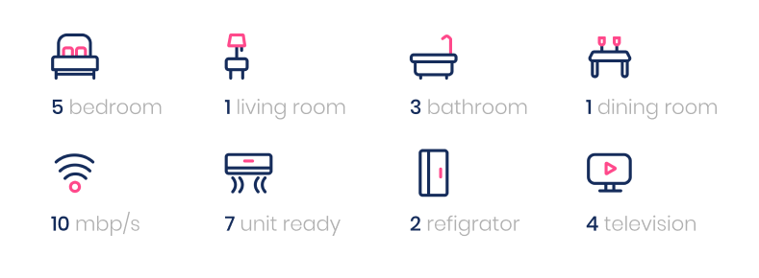

**public** class Room

**{**

// ...

**public int NumberOfBedrooms { get; set; }**

**public** int NumberOfLivingRooms **{** **get;** **set;** **}**

**public** int NumberOfBathrooms **{** **get;** **set;** **}**

**public** int NumberOfDiningRooms **{** **get;** **set;** **}**

**public** int UnitsReady **{** **get;** **set;** **}**

**public** int NumberOfRefrigerators **{** **get;** **set;** **}**

**public** int NumberOfTelevisions **{** **get;** **set;** **}**

**}**

**انا متوقع ان اللي هيحجز في القوضه لو معاه اشخاص يكون ال max هوا نفس العدد للـ Number Of Bedrooms، لكن الفكره اللي هيحجز ده هيكون معاه اطفال فكده هنديهم سعر مُختلف ولا بنفس السعر للـ Adult؟**

**الفكره برضه هل دول ثوابت بيكونوا في ال Rooms ولا دول بيكونوا تبع RoomFacility**

// Room.cs

**public** class Room

**{**

// ...

**public** ICollection**<**RoomFacility**>** Facilities **{** **get;** **set;** **}**

**}**

// RoomFacility.cs

**public** class RoomFacility

**{**

**public** int Id **{** **get;** **set;** **}**

**public** string Name **{** **get;** **set;** **}** // e.g., "Free WiFi", "Air Conditioning", "Swimming Pool"

**public** bool IsAvailable **{** **get;** **set;** **}** // Whether this facility is currently available

// Foreign key

**public** int RoomId **{** **get;** **set;** **}**

**public** Room Room **{** **get;** **set;** **}**

**}**

**Room Feedback, Comment**

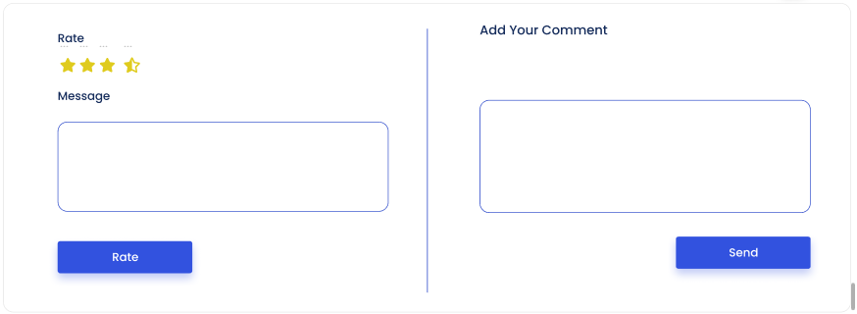

**هنلاقي هنا عندنا 2 TextAreas (طبعاً لازم تكون Logged in as Customer عشان تقدر تبعت اياً منهم لكن مينفعش كـ Stuff)**

// RoomComment.cs

**public** class RoomComment

**{**

**public** int Id **{** **get;** **set;** **}**

**public** string Content **{** **get;** **set;** **}**

**public** DateTime CreatedAt **{** **get;** **set;** **}**

**public** string UserId **{** **get;** **set;** **}** // Assuming user authentication

// Foreign key

**public** int RoomId **{** **get;** **set;** **}**

**public** Room Room **{** **get;** **set;** **}**

**}**

// RoomFeedback.cs

**public** class RoomFeedback

**{**

**public** int Id **{** **get;** **set;** **}**

**public** string Message **{** **get;** **set;** **}**

**public** int Rating **{** **get;** **set;** **}** // Rating from 1 to 5

**public** DateTime CreatedAt **{** **get;** **set;** **}**

**public** string UserId **{** **get;** **set;** **}** // Assuming user authentication

// Foreign key

**public** int RoomId **{** **get;** **set;** **}**

**public** Room Room **{** **get;** **set;** **}**

**}**

**Room Booking**



// Room.cs

**public** class Room

**{**

// ...

**public** decimal PricePerNight **{** **get;** **set;** **}**

**public** decimal DiscountPercentage **{** **get;** **set;** **}**

**public** int Capacity **{** **get;** **set;** **}**

**public** bool IsTaken **{** **get;** **set;** **}**

// Navigation properties

**public** ICollection**<**RoomBooking**>** Bookings **{** **get;** **set;** **}**

**}**

المفروض ان السيناريو اللي هيمشي التالي:

* 1. أن ال Room يكون فيها Bookings من Customers مختلفين وكل Book فيه ال Status واللي يوافق عليه هيكون Stuff
  2. بالتالي ال Status تكون Approved في ال Booking Row بالعمليه
  3. وهنا ال IsTaken flag يكون بـ TRUE

**public** class RoomBooking

**{**

**public** int Id **{** **get;** **set;** **}**

**public** DateTime CheckInDate **{** **get;** **set;** **}**

**public** DateTime CheckOutDate **{** **get;** **set;** **}**

**public** int NumberOfGuests **{** **get;** **set;** **}**

**public** decimal TotalPrice **{** **get;** **set;** **}**   
 // e.g., "Pending", "Confirmed", "Cancelled"

**public** string BookingStatus **{** **get;** **set;** **}**

**public** DateTime CreatedAt **{** **get;** **set;** **}**

**public** string UserId **{** **get;** **set;** **}** // Assuming user authentication

// Foreign key

**public** int RoomId **{** **get;** **set;** **}**

**public** Room Room **{** **get;** **set;** **}**

**}**